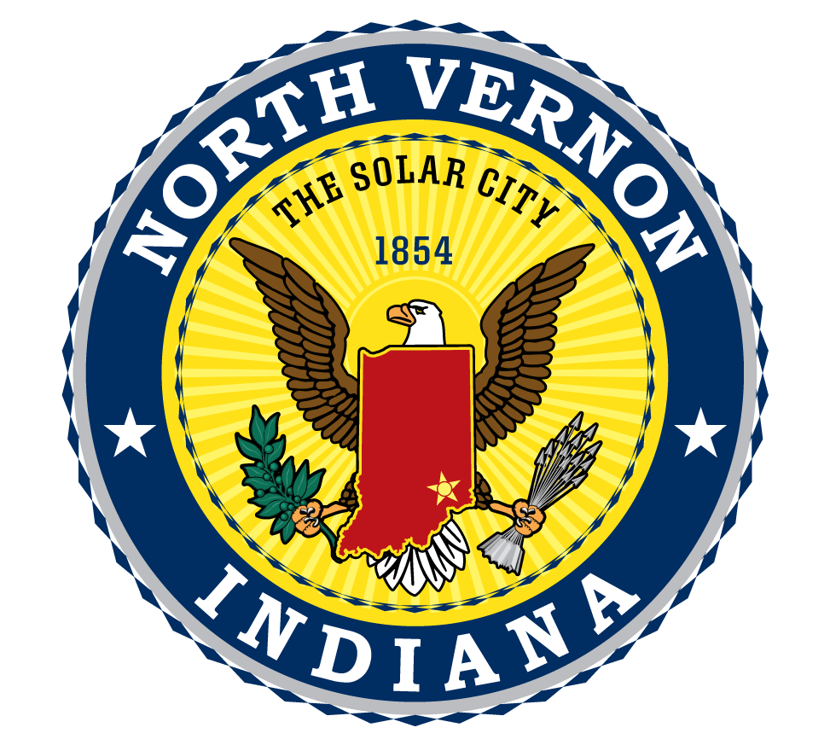
City of North Vernon
143 E Main St
North Vernon, IN 47265

February 27, 2023

Press Release

The North Vernon Redevelopment Commission (NVRC) Housing created the North Vernon Housing Property Revitalization Program to provide incentives to home builders in amounts between $5,000 and $15,000 to create housing here in the City of North Vernon. The funds will incentivize builders to utilize vacant or blighted properties in an effort to help clean up blighted lots as well as create more housing opportunities and draw new residents to the area.

In 2018, a city housing study was conducted and subsequently revealed that the city was in need of approximately 400 residences in order to satisfy the market need for housing based on the number of houses available versus those looking for housing and the current population.

The hope with this new program is that builders will choose in fill lots and properties that are blighted, meaning they are visually unattractive to the eye as well as a potential threat to human health, safety, and public welfare, and clean them up. Additionally, the program is hoping that new, affordable housing will draw in a new and younger generation to the community.

The incentives fall under three categories:

- Vacant lots: A vacant lot previously platted, assigned a parcel ID number, and located within the city with water and sewer availability may qualify for a grant of $5,000 in the event a new residential dwelling is constructed thereupon. Upon application and on a case-by-case basis an additional $2,500 may be made available.
- Previously improved lots: A lot with prior improvements needing to be demolished that has been previously platted, assigned a parcel ID number, and located within the City with water and sewer availability shall qualify for a grant of up to $15,000 (depending upon the extent of demolition required [for example, demolition of a large house is more expensive than demolition of a shed or garage) in the event a new residential dwelling is constructed thereupon. The Commission must approve the building specifications prior to construction, which approval will not be unreasonably withheld if the plans are complementary to the surrounding neighborhood.
- Undeveloped ground: In the event that a property owner desires to subdivide ground suitable for residential housing the Commission will seek to assist said property owner through significant financial assistance. This assistance shall be available on a case-by-case basis and will be dependent upon funds available to the Commission from time to time. Any such new development must meet the county subdivision control ordinance and must have reasonable restrictive covenants created to preserve the wellbeing and future appearance of the neighborhood. neighborhood. Proposed restrictive covenants must be submitted and approved prior to grant award.

General Information:

- The amount of assistance and method of payment shall be on a case-by-case basis and developers should contact the Commission to initiate discussions leading toward a development agreement.
- Developers will be required to show proof of financial ability to support the project and past experience.
- The Commission must approve the building specifications prior to construction, which approval will not be unreasonably withheld if they plans are complementary to the surrounding neighborhood.
- The city itself isn’t investing in purchasing lots and developing housing units.
- Anyone interested in building housing within the City of North Vernon is welcome to apply to receive funds through this program.
- Funding for the new program will come from the Redevelopment Commission TIF district.
- The program requires a 1400 square foot minimum, stick built homes excluding porches and garages.
- The funds being offered by NVRC with this program may offer financial gap funding when building a home, especially to young homeowners just starting out. Focus of the program is for home resale to a homebuyer.
- Money will be granted at the time of the certificate of occupancy.

Benefits included:

- Removal of blighted property
- Increasing the city’s property tax base
- Increase funding for the school system with increase in housing (more housing = more families = more students = higher enrollment)
- More traffic for local small businesses through the increased population
- Improved quality of housing in North Vernon
- The incentive will give local contractors the ability to make a profit and grow their small businesses.

Applications

For properties that have a viable reuse, the City of North Vernon will request proposals from developers, individuals, non-profit developers, for-profit developers, or partnerships including any type of development entity. Application will be forwarded to Administrative Resources association who will act as program manager and fiscal agent for the programs. Application will need to identify the proposed reuse of the property, scope of rehabilitation/construction, financing, property management, or other related information relevant to the details of their development.

The purpose of this application process is assessing the needs and financial gap that will help to trigger measurable change to the property; thus, applications may include more than one property. The application process is assessed on a case by case basis. Applications must follow the submission format outlined and include applicable supporting documentation.

Application Criteria: The decision to award a grant will be based on the need of the development and developer, type of property being developed and the best use of the property. The application, individual or business must demonstrate that their proposed development will have a positive impact on the community/area, impacts housing needs and has sufficient financing to achieve its redevelopment development plan.

A property lien/restrictive covenant and restrictive covenant with 3 year terms will be required of winning bidders. The value of the lien/restrictive covenant will consist of any lien/restrictive covenants forgiven equal to the value of the grant. The covenant will also require the developer to begin within 3 months of grant award and complete work in 12 months; as well as maintain property insurance during the construction of the home.

Application Steps:

- Publish notice to developers
- Applications received by Clerk Treasurer
- Application will be forwarded to ARa for review
- ARa may contact applicant for more information or clarity, run credit report, etc.
- ARa will prepare summary review of applications and supporting documentation
- ARa will send summary with recommendations to the commission.
- Approval or denial is then made by the NVRC
- If approved, ARa will prepare property documents included property agreement and covenant with 3 year terms for amount of the grant award.

Scoring/review Criteria:

- Proposed reuse (number of homes/units, estimated costs, home resale, etc.)
- Financial capacity (funding in place, credit history, etc.)
- Rehab projects need to include investment and renovation plans (scope of work)
- New construction needs to include floor plans and renderings
- History of development, construction experience including past projects/properties in city

The city will begin accepting applications on March 6, 2023. Applications are available at the Office of Clerk Treasurer, City of North Vernon, 143 E Main St, North Vernon, IN 47265 or on the city’s website: https://www.northvernon-in.gov/

